Survivor

DESIGN DOCUMENT

By Aizin for the 2022 Pirate Software Game Jam

**Introduction** **2**

Game Summary 2

Inspiration 2

Player Experience 2

Platform 3

Development Software 3

Genre 3

Target Audience 3

**Concept** **3**

Gameplay overview 3

Theme Interpretation (Sacrifice Is Strength) 4

Primary Mechanics 4

Secondary Mechanics 5

**Art** **6**

Theme Interpretation 6

Design 6

**Audio** **7**

Music 7

Sound Effects 7

**Game Experience** **7**

UI 7

Controls 7

**Development Timeline** **8**

## **Introduction**

### Game Summary Pitch

The game is a top-down 2D survival game where the player battles against relentless waves of enemies in an ever-changing, procedurally generated field. The core gameplay revolves around defeating enemies to collect mana orbs, which allow the player to level up and unlock new abilities and weapons. As the game progresses, the challenge escalates, pushing the player to adapt and persevere.

### Inspiration

**Snakebird**

This game draws inspiration from popular titles such as **Vampire Survivors**, **Holocure**, and **Magic Survival**. These games share a core theme of growth through overcoming adversity, which aligns with the theme of this project.

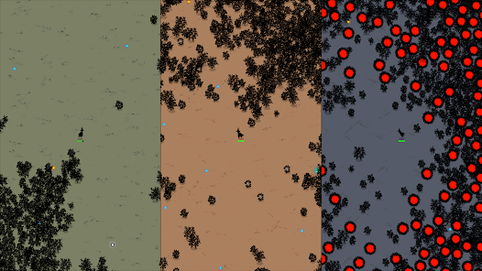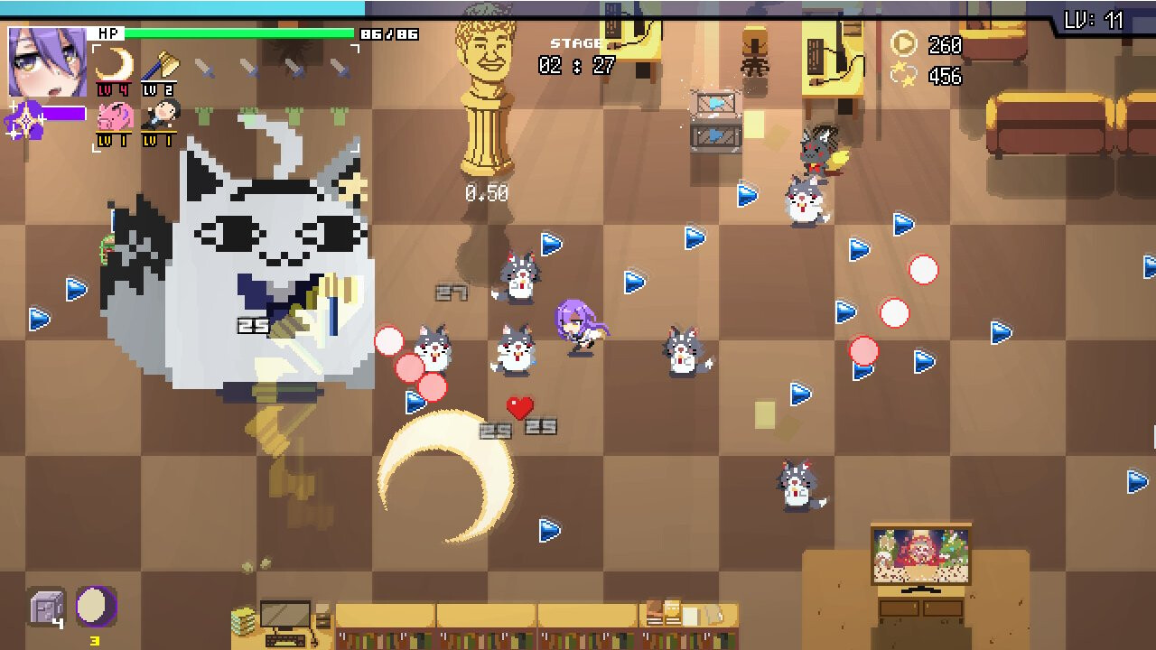

### Player Experience

The player will experience the thrill of rapid progression and escalating challenges. As the game becomes more difficult, the player will gain satisfaction from mastering abilities, synergizing weapons, and surviving increasingly hostile environments. The core theme of never giving up is reinforced through gameplay that rewards persistence and adaptability.

### Platform

The game is developed for Windows PC

### Development Software

The development process uses the following tools:

* Unity for game engine and scripting.
* Aseprite for creating pixel art assets.
* Krita for additional art and concepts.
* LMMS for music and sound effects.
* VS Code for scripting and coding.

### Genre

Singleplayer, survival, action, shoot ‘em all.

### Target Audience

The game is designed for teenagers and young adults who enjoy fast-paced, skill-based gameplay with progression systems and procedural generation.

## Concept

### Gameplay overview

The player controls a character armed with basic abilities and weapons, starting with simple projectile attacks. Enemies are defeated to collect mana orbs, which contribute to leveling up. Leveling up allows the player to acquire new abilities, enhance existing weapons, or unlock additional weapons. The flat, procedurally generated fields present dynamic obstacles and limitless gameplay variety.

### Theme Interpretation (****Never Giving Up****)

The theme is embodied in the escalating difficulty of the game. As waves of enemies grow in number and strength, the player must persist, adapt, and make strategic choices to survive. The gameplay creates a narrative of resilience and determination, with the player’s progress reflecting their perseverance.

### Primary Mechanics

| **Mechanic** |
| --- |
| **Mana Orbs** a  Enemies drop mana orbs upon death, which increase the player’s level-up percentage. Upon leveling up, the player selects a new ability or weapon. |
| **Projectile Weapons** a  The player starts with throwing knives that fire in four straight directions and four diagonal directions. |
| **Melee Weapons** a  Abilities such as a garlic aura provide close-range damage. |
|  |

### Secondary Mechanics

| **Mechanic** |
| --- |
|  |

## Art

### Theme Interpretation

The pixel art style is colorful and engaging, designed to evoke a sense of vibrancy amidst chaos. Environments and characters are detailed yet minimalistic to ensure clarity during gameplay. Bright colors are used to emphasize pickups, abilities, and enemy attacks.

### Design

The game features procedurally generated flat fields, created using tilemaps and prefabs. These environments are designed to provide variety while maintaining a consistent challenge level.

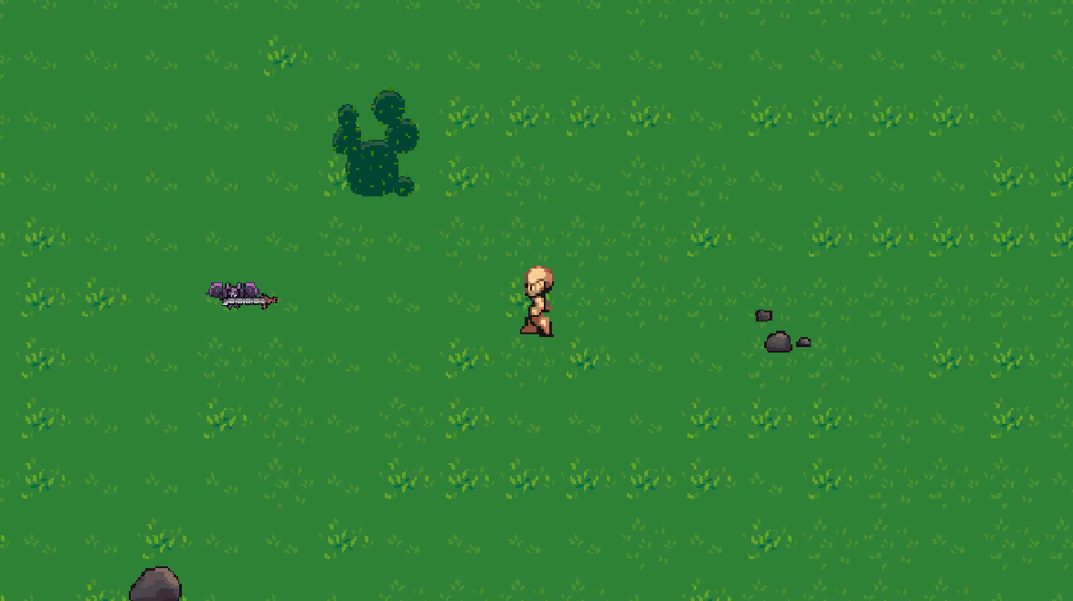

*\*an example of the tileset and art style\**

## Audio

### Music

Minimalistic music enhances the sense of focus and immersion. Tracks are synthesized, using repetitive yet evolving patterns to match the escalating intensity of the game.

### Sound Effects

Sound effects are synthesized and designed to provide clear feedback for player actions, such as collecting mana orbs, leveling up, and attacking enemies.

## Game Experience

### UI

The user interface is simple and intuitive, designed to integrate seamlessly with the game’s visual style. The level-up interface is designed to present new abilities and weapons clearly, ensuring the player can make strategic decisions quickly.

### Controls

**Keyboard**

Arrow keys / WASD

## Development Timeline

**MINIMUM VIABLE PRODUCT**

| **#** | **Assignment** | **Type** | **Status** | **Finish By** | **Notes** |
| --- | --- | --- | --- | --- | --- |
| 1 | Design Document | Other | Finished | November 22, 2024 |  |
| 2 | Create player | Art | Finished | November 23, 2024 | Placeholder character put |
| 3 | Create Enemy | Art | Finished | November 23, 2024 | Placeholder enemy put |
| 4 | Create Projectiles | Art | Finished | November 23, 2024 | Placeholder Weapons put |
| 5 | Create Tilemaps | Art | Finished | November 23, 2024 | Placeholder textures put |
| 6 | Simple player movement | Coding | Finished | November 25, 2024 | All movement directions with an animated character |
| 7 | Procedural map generation | Coding | Finished | November 28, 2024 | Generation of tilemaps as chunks. |
| 8 | Projectile weapons | Coding | Finished | November30, 2024 | Moving in cardinal and diagonal directions |
| 9 | Melee Weapons | Coding | Finished | December 1, 2024 | Garlic Aura added |
| 10 | Basic enemies with simple AI | Coding | Finished | December 7, 2024 | Enemies following the player |
| 11 | Level up mechanics | Coding | Finished | December 13, 2024 | Leveling up by picking up gems |
| 12 | Enemy loot | Coding | Finished | December 15, 2024 | Enemies drop gems when they die |
| 13 | Health System | Coding | Finished | December 18, 2024 | Player can hurt and get hurt |
| 14 | Advanced Spawners | Coding | Not started |  |  |

**BEYOND (if ahead of schedule / extra time)**

Depending on development progress, additional features may include complex synergies between abilities, environmental hazards, and a wider variety of enemy behaviors and attacks.